Program Introduction：

This project is a customized software product for catering enterprises (restaurants and hotels), including two parts: system management backend and mobile application. The system management backend is mainly provided for the internal staff of the restaurant company, which can manage and maintain the restaurant's classification, dishes, packages, orders, staff, etc. The mobile application is mainly provided for consumers to use, which can browse dishes, add shopping cart, place orders online, etc.

Backend management Page: <http://localhost:8080/backend/index.html>

Front-end Page: http://localhost:8080/front/index.html

1、Management side

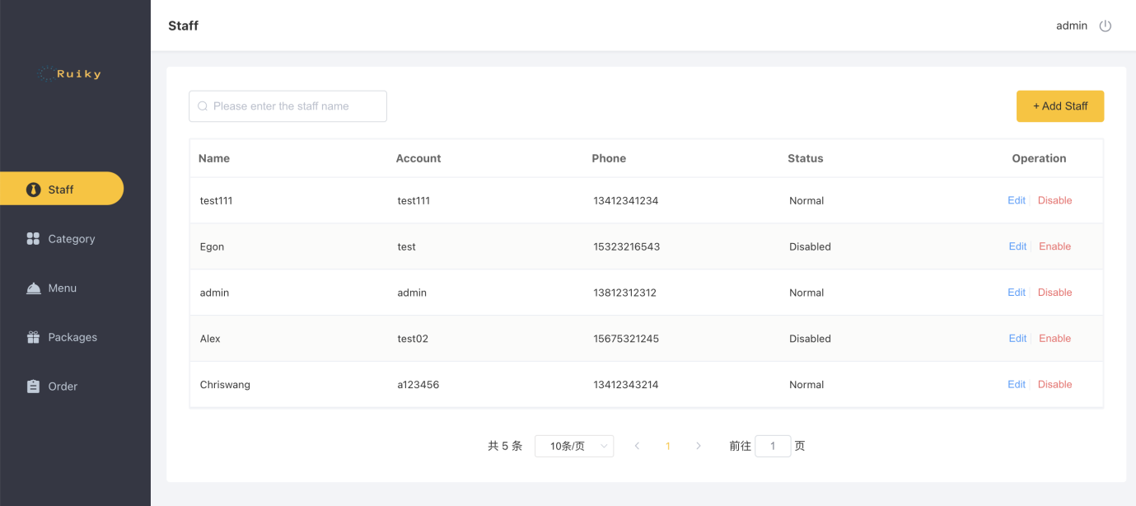

The restaurant is used by internal staff. The main features are:

|  |  |
| --- | --- |
| Module | Description |
| Login/Logout | Internal employees must be logged in to access the system management background |
| Staff management | Staff management The administrator can manage the staff information in the system background, including search, add, edit, disable and other functions |
| Category management | Mainly for the current restaurant operation of the food classification or set meal classification management maintenance, including search, add, modify, delete and other functions |
| Menu management | Menu management Mainly maintain the information of dishes under each category, including search, add, modify, delete, start sale, stop sale and other functions |
| Package  management | Mainly maintain the current restaurant package information, including search, add, modify, delete, start selling, stop selling and other functions |
| Order details | Mainly maintain the user's order information in the mobile terminal, including search, cancellation, delivery, completion, and order report download functions |

1. User side

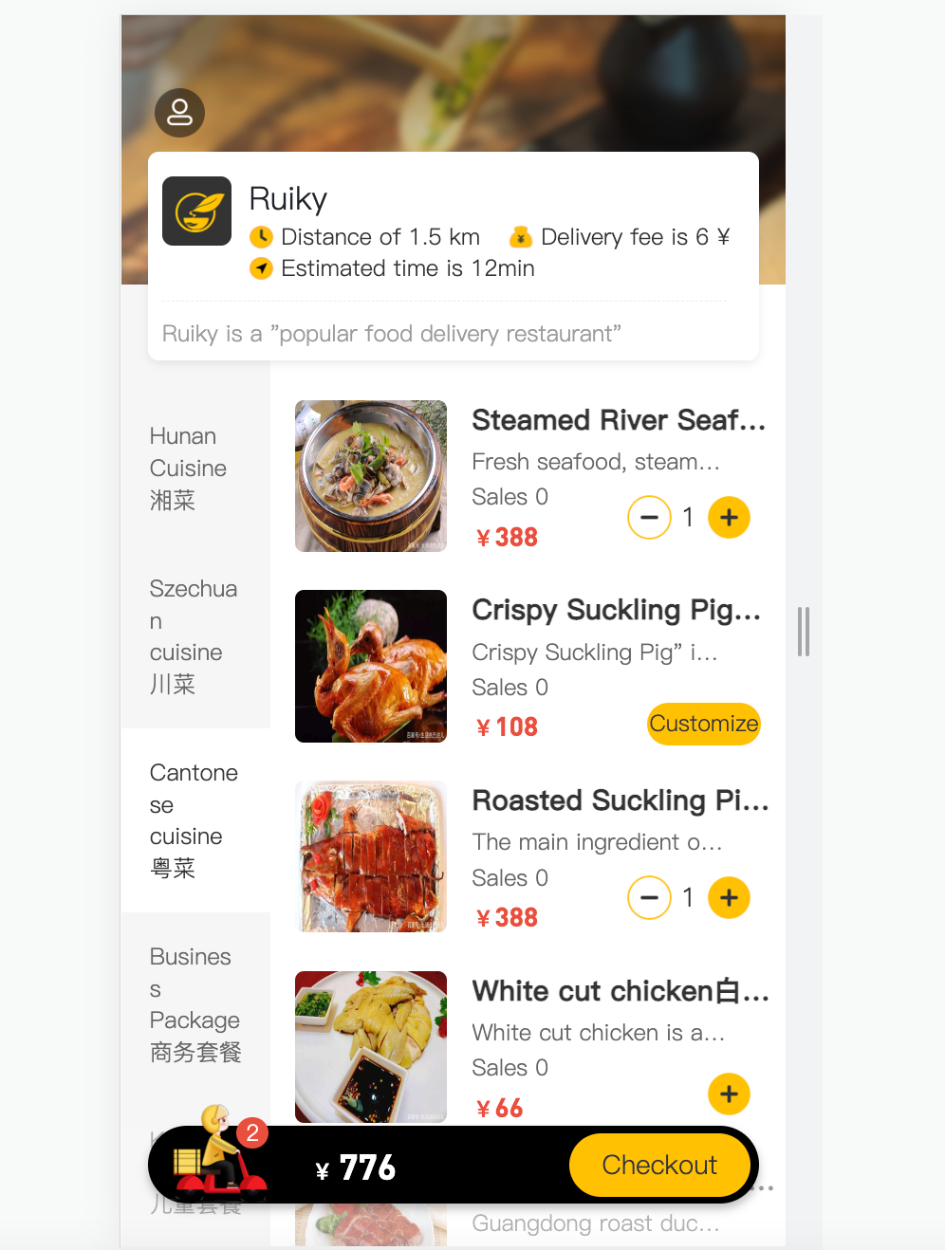

Mobile applications are primarily for consumer use. The main functions are:

|  |  |
| --- | --- |
| Module | Description |
| Login/Logout | On the mobile side, users also need to login and use the app to order food. |
| Order-Menu | Order-Menu In the ordering interface, it will show the category of dishes/packages, and load the information of the dishes according to the currently selected category for users to check and choose. |
| Order-Cart | The dishes selected by the user will be added to the user's shopping cart, mainly including check cart, add cart, delete cart, clear cart and other functions |
| Order payment | After the user selects the dish/package, he/she can pay for the shopping cart items, and then he/she needs to pay for the order. |
| Personal information  management | In the personal center page, the basic information of the current user will be displayed, the user can manage the delivery address, and can also check the historical order data. |

1. User Roles

|  |  |
| --- | --- |
| Role | Permission |
| Backstage system administrator | Login to the backstage management system, have all the operation rights in the backstage system. |
| Backstage system general staff | Login to the backstage management system, manage dishes, packages, orders, etc. (not including staff management). |
| C-side user | Login to the mobile application, can browse dishes, add shopping cart, set address, online order, etc. |